Tech Saksham

Final Project Report

“ONLINE ATTENDANCE MANAGEMENT SYSTEM ”
“Rajiv Gandhi University of Knowledge Technologies ”
ROLL NO | NAME
R170692 | K.Ramani

P.Ragavan | Trainer Name

ABSTRACT

Student attendance management system deals with the maintenance of the student’s attendance details. It is generates the attendance of the student on basis of presence in class. It is maintained on the daily basis of their attendance. the staffs will be provided with the separate username & password to make the student’s status. The staffs handling the particular subjects responsible to make the attendance for all students. Only if the student present on that particular period, the attendance will be calculated. The students attendance reports based on weekly and consolidate will be generated.

INDEX

Abstract...........................................................................................................4
1. Introduction..................................................................................................1
1.1 Purpose...................................................................................................1
1.2 System Scope.........................................................................................1
2. System Study...............................................................................................2
2.1 Existing System......................................................................................2
2.2 Disadvantages........................................................................................2
2.3 Proposed System....................................................................................2
2.3.1 Economical feasibility.......................................................................2
2.3.2 Technical feasibility..........................................................................2
2.3.3 Operational feasibility.......................................................................2
2.4 Overview of Software..............................................................................3
2.5 Hardware Specification...........................................................................4
2.6 Software Requirement............................................................................4
3. System Design.............................................................................................4
3.1 DFD Diagrams.........................................................................................4
3.2 UML Diagrams:......................................................................................5
3.3 Entity Relationship Diagram.....................................................................6
4. System Testing..........................................................................................7
4.1 Functional Testing.................................................................................7
4.2 Structural Testing.................................................................................7
4.3 System Testing.....................................................................................7
4.3.1 Test Cases......................................................................................8
8. List of Figures.............................................................................................11
9. References.................................................................................................14

CHAPTER 1
INTRODUCTION
  - In this technical era information plays vital role in any once life. Likewise for a University sharing of the features, placements, faculty, student’s achievements, location etc. are important and this can be achieved easily by maintaining a website because it will be available throughout the globe and updating of the website lets include the new features and new data so that everyone can see the same. This website is user friendly and responsive that is whatever the size the viewing experience makes to comfortable to look in to it. Basically websites gives best experience in the laptops, desktops but making the site as responsive the same thing can be achieved through the small size screens like tablets, mainly phones. This website enhances the popularity of the college within less time as it is available over the internet because many of them now a day’s most of the people first prefer to check details and visit later on. The system allows admin to updates the events quickly in online notice board and those are reflected on user side so user can get updates .In this website the admin no need to worry on data by single click admin can update events and more. It uses PHP and MySQL database. It has two modules i.e. Admin: Admin is the super user of the website who can manage everything on the website. Admin can log in through the login page and can manage whole website for example he can update events on login. User: User can visit the application through a URL. 1.1 Purpose “Attendance Management System” is software developed for maintaining the attendance of the student on the daily basis in the collage. Here the staffs, who are handling the subjects, will be responsible to mark the attendance of the students. Each staff will be given with a separate username and password based on the subject they handle. An accurate report based on the student attendance is generated here. This system will also help in evaluating attendance eligibility criteria of a student. Report of the student’s attendance on weekly and monthly basis is generated.

1.2 System Scope Scope of the software:-
- Shows the attendance of every subjects .
- Displays students attendance •
- shows the attendance percentage
- Lists the shart attendance students
2. System Study This chapter deals with the analysis of the system proposed by our guide. It covers the features, advantages and disadvantages of both the system.
2.1 Existing System The Existing system is a manual entry for the students. Here the attendance will be carried out in the hand written registers. It will be a tedious job to maintain the record for the user. The human effort is more here. The retrieval of the information is not as easy as the records are maintained in the hand written registers. This application requires correct feed on input into the respective field. Suppose the wrong inputs are entered, the application resist to work. so the user find it difficult to use.
2.2 Disadvantages
• Not flexible
• Data may not be perfect human error
• Manual work required
2.3 Proposed System To overcome the drawbacks of the existing system, the proposed system has been evolved. This project aims to reduce the paper work and saving time to generate accurate results from the student’s attendance. The system provides with the best user interface. The efficient reports can be generated by using this proposed system.
2.3.1 Economical feasibility Development of this application is highly economically feasible. The only thing to be done is making an environment with an effective supervision. It is cost effective in the sense that has eliminated the paper work completely. The system is also time effective because the calculations are automated which are made at the end of the month or as per the user requirement.
2.3.2 Technical feasibility The technical requirement for the system is economic and it does not use any other additional Hardware and software. Technical evaluation must also assess whether the existing systems can be upgraded to use the new technology and whether the organization has the expertise to use it. Install all upgrades framework into the .Net package supported widows based application. this application depends on Microsoft office and intranet service ,database. Enter their attendance and generate report to excel sheet.
2.3.3 Operational feasibility The system working is quite easy to use and learn due to its simple but attractive interface. User requires no special training for operating the system. Technical performance include issues such as determining whether the system can provide the right information for the Department personnel student details, and whether the system can be organized so that it always delivers this information at the right place and on time using intranet services. Acceptance revolves around the current system and its personnel
. 2.4 Overview of Software
APACHE
The Apache HTTP Server Project is an effort to develop and maintain an open-source HTTP server for modern operating systems including UNIX and Windows. The goal of this project is to provide a secure, efficient and extensible server that provides HTTP services in sync with the current HTTP standards. The Apache HTTP Server was launched in 1995 and it has been the most popular web server on the Internet since April 1996. It has celebrated its 20th birthday as a project in February 2015.
PHP
- PHP stands for PHP: Hypertext Preprocessor.
- PHP is a server-side scripting language, like ASP.
- PHP scripts are executed on the server.
- PHP supports many databases (MYSQL, Informix, Oracle, Sybase, Solid, Generic ODBC, etc.).
- PHP is an open source software.
- PHP is free to download and use.
MYSQL
- MYSQL is a database server
- MYSQL is ideal for both small and large applications
- MYSQL supports standard SQL
- MYSQL compiles on a number of platforms
- MYSQL is free to download and use
- How to access MySQL:

2.5 Hardware Specification
User side:
• Not required any hardware.
• Required only internet access and computer.
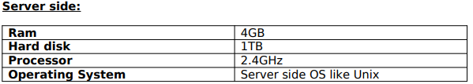
2.6 Software Requirement
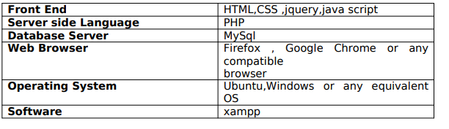
3. System Design
The system design is needed for information processing technology and the user interface development analysis. It contain a high level overview of the organization in which the common activities, processes and products are described in relation to how they create, use and modify information. Below given dfd’s can be used to describe the overall user interface:
3.1 DFD Diagrams
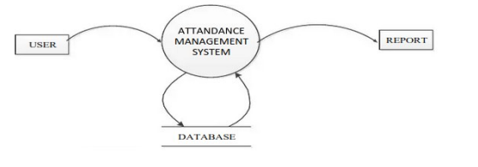

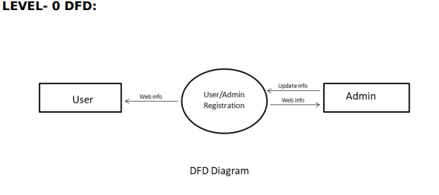

3.2 UML Diagrams:
Actor: A coherent set of roles that users of use cases play when interacting with the use cases. An observable result of value of an actor.
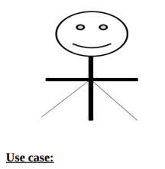

A description of sequence of actions, including variants, that a system performs yields an observable result of value of an actor. actor diagram is drawned in a eclipse shape. UML stands for Unified Modelling Language. UML is a language for specifying, visualizing and documenting the system. This is the step while developing any product after analysis. The goal from this is to produce a model of the entities involved in the project which later need to be built. The representation of the entities that are to be used in the product being developed need to be designed.
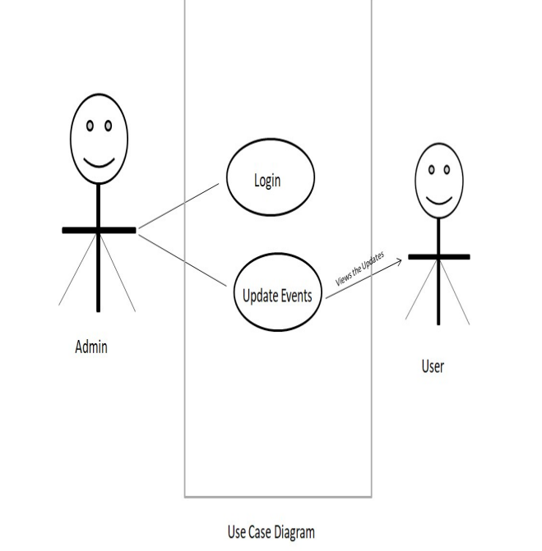
3.3 Entity Relationship Diagram
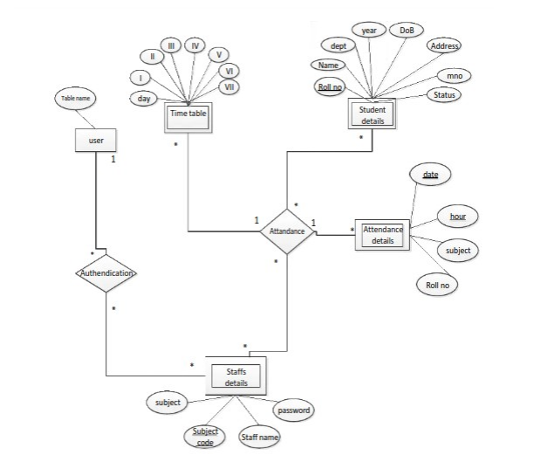
4. System Testing
System testing is normally carried out in a planned manner according to the system test plan document. The system test plan identifies all testingrelated activities that must be performed, specifies the schedule of testing, and allocates resources. It also lists all the test cases and the expected outputs for each test case. Here the modules are integrated in a planned manner
. 4.1 Functional Testing
Functional testing refers to tests that verify a specific action or function of the code. These are usually found in the code requirements documentation, although some development methodologies work from use cases or user stories. Functional tests tend to answer the question of "can the user do this" or "does this particular feature work". Some examples of functional testing done in our project:
• By checking all the login modules, it is ensured that only registered users can access all the facilities.
• 4.2 Structural Testing
Structural testing is also called White box testing. This means a testing technique whereby explicit knowledge of the internal workings of the item being tested is used to select the test data. White box testing uses specific knowledge of programming code to examine outputs. The test is accurate only if the tester knows what the program is supposed to do. He or she can then see if the program diverges from its intended goal. White box testing does not account for errors caused by omission, and all visible code must also be readable.
4.3 System Testing System testing of software or hardware is testing conducted on a complete, integrated system to evaluate the system's compliance with its specified requirements. System testing falls within the scope of black box testing, and as such, should require no knowledge of the inner design of the code or logic.As a rule, system testing takes, as its input, all of the "integrated “software components that have successfully passed integration testing and also the software system itself integrated with any applicable hardware system(s). The purpose of integration testing is to detect any inconsistencies between the software units that are integrated together (called assemblages) or between any of the assemblages and the hardware. System testing is amore limiting type of testing; it seeks to detect defects both within the "inter-assemblages" and also within the system as a whole. System testing is performed on the entire system in the context of a Functional Requirement Specification(s) (FRS) and/or a System Requirement Specification (SRS).System testing is an investigatory testing phase, where the focus is to have almost a destructive attitude and tests not only the design, but also the behaviour and even the believed expectations of the customer. It is also intended to test up to and beyond the bounds defined in the software/hardware requirements specification(s).
4.3.1 Test Cases A test case in software engineering is a set of conditions or variables under which a tester will determine whether an application or software system is working correctly or not.
Unit Test Cases
The software is being divided into different components and unit testing is performed on each of these modules. This section is repeated for all components.
Integration Test cases
Integration testing is a part of stress testing which involves integrating the components to create a system or sub-system. It may involve testing an increment to be delivered to the customer. In integration testing, the test team has access to the system source code. The system is tested as components are integrated.
Validation Test cases
This testing is done to see whether the integrated software is valid according to the user needs.
5. Database Schema
The goal of database design is to ensure that the data is represented in such a way that there is no redundancy and no extraneous data is generated, thus generate relationship in as high an order as possible. Having identified all the data on the system it is necessary to at the logical database design. Database design involves designing the conceptual model of the database. This model is independent of the physical representation of the data. Once the conceptual model is designed, it can be mapped to the DBMS/RDBMS that is actually being used. Following are tables that have been used in this project:-

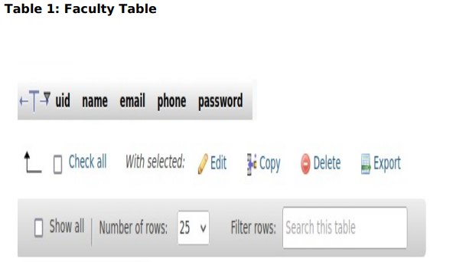
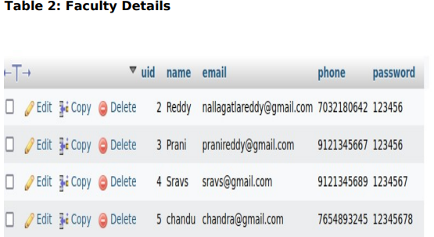

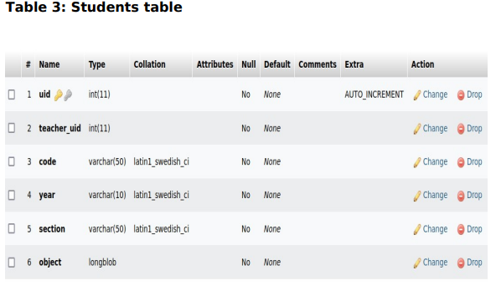

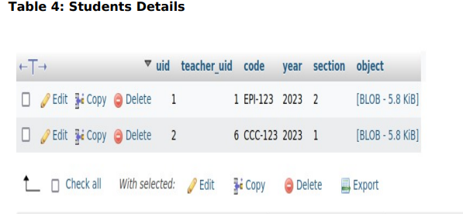
6 Conclusion

6.1 Conclusion
To conclude, Project Data Grid works like a component which can access all the databases and picks up different functions. It overcomes the many limitations incorporated in the attendance.
➢ Easy implementation Environment
➢ Generate report Flexibly
6.2 Scope for future development
The project has a very vast scope in future. The project can be implemented on internet in future. Project can be updated in near future as and when requirement for the same arises, as it is very flexible in terms of expansion. With the proposed software of database Space Manager ready and fully functional the client is now able to manage and hence run the entire work in a much better, accurate and error free manner. The following are the future scope for the project. ➢ Discontinue of particular student eliminate potential attendance.
➢ Bar code Reader based attendance system.
➢ Individual Attendance system With photo using Student login.
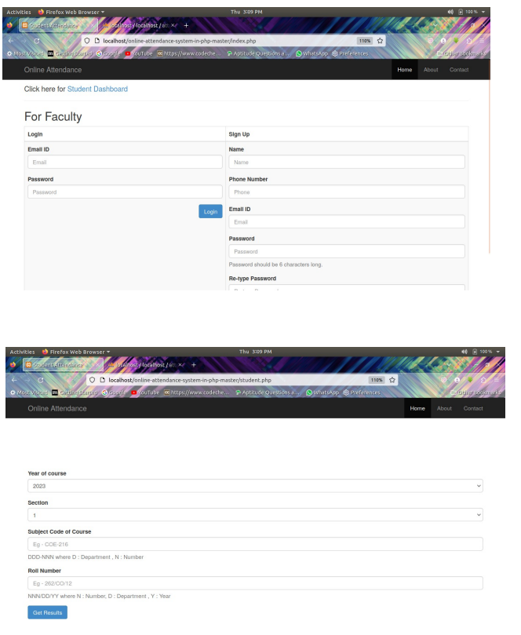
8. List of Figures

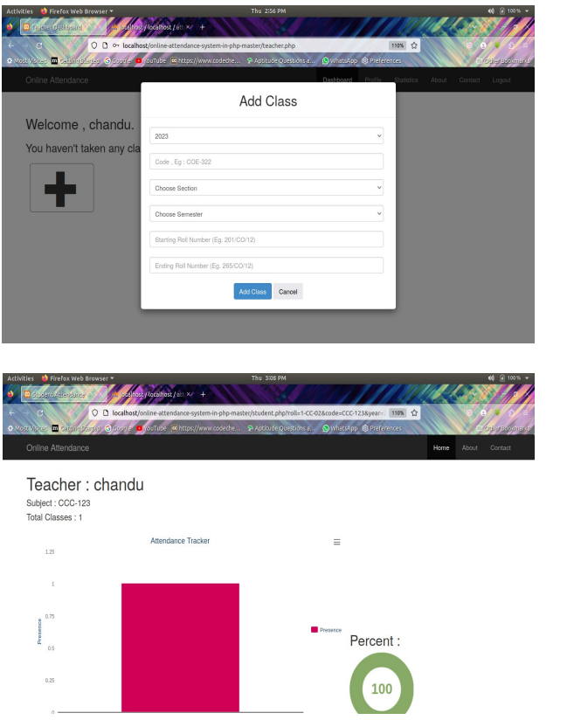

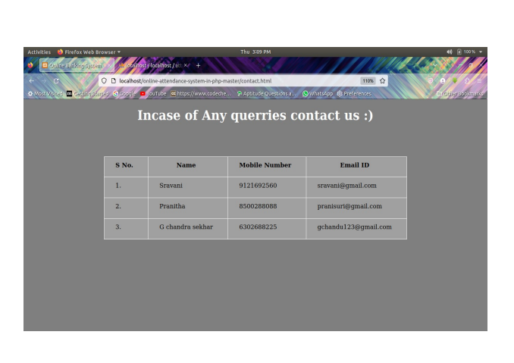

9. References
For HTML, CSS, Javascript :
https://www.w3schools.com/html/default.asp
https://www.w3schools.com/css/default.asp
https://www.w3schools.com/js/default.asp
https://www.youtube.com/c/Freecodecamp
For PHP:
https://www.w 3schools.com/php/default.asp
https://www.sitepoint.com/php/ https://www.php.net/
For MySQL:
https://www.mysql.com/
https://www.mysqltutorial.org
For XAMPP:
https://www.apachefriends.org/download.html
Udemy:
The Complete 2022 Web Development Bootcamp-Dr. Angela Yu
LinkedIn Learning:
Become a Full-Stack Web Develope

